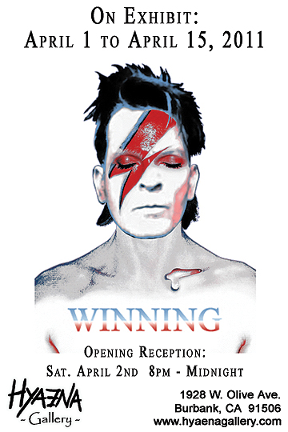
WINNING
The Charlie Sheen Exhibit
In a grand effort to Plan Better, Hyaena is proud to announce “WINNING: the Charlie Sheen Exhibit.” Running from April 1 – April 15, this is no April Fool’s joke. It is a
bold exploration of pop culture and our concept of celebrity, revolving around America’s favorite Troll-Hunting Warlock.
Love him or hate him, Sheen is captivating our media and collective consciousness. In the face of scandal, he avoided the emasculation of apology that plagues so many in the public eye (Bill Clinton, Tiger Woods, David Duchovny, etc.). Instead he stood tall and blatantly took ownership of his vices, shocking the entertainment world with his honest defiance. In a culture that loves to place celebrities on a pedestal and then viciously tear them down at every opportunity, Sheen threw a curveball at the hypocrisy, grabbed his Goddesses, and stepped up to his throne at the Sober Valley Lodge leaving the naysayers to their own devices.
With his quick wit Sheen creates some of the most incredible sound bites on an hourly basis to feed to the masses. His innovative use of available technology and social media keeps his Torpedoes of Truth on the tips of everyone’s tongue. Whether you think Sheen is insane or a genius, this is the first time we have truly been allowed to have such direct real time access to a celebrity’s thoughts. Will he go down in a drug-fueled orgy of madness…or is he simply making a mockery of us all?
This art exhibit at Hyaena Gallery, “WINNING,” gathers a select group of artists from our roster: Jim Wirt (author of “Coloring Book Land”), Jeff Rebner (from “American Dad”), Ken Stranahan (award winning VFX artist), Chris Mann, Big Tasty, Lou Rusconi, Donnie Green, Jessica Ward, Nicolas Caesar, and more! They are taking no prisoners and have gone balls out to create a killer show that guarantees some incredible surprises.
In true Hyaena fashion we are using this opportunity to poke a little fun at the media and ourselves, and to pay tribute to a man who is not afraid to lay down his own path outside the mainstream and walk it proudly.
Oh...and the gallery is mere blocks away from Warner Brothers Studios
where Two and a Half Men was filmed.
WINNING
The Charlie Sheen Exhibit
The are exhibit runs from April 1, 2011 until April 15, 2011
Please join us for our Opening Reception on
Saturday, April 2 2011 (8pm-midnight)
Free Admission / Open to the Public
Hyaena
1928 W. Olive Ave.
Burbank, CA 91506
U.S.A.
818-972-2448
www.hyaenagallery.com
For Press Inquiries, email Bill Shafer at hyaenaking@hyaenagallery.com
To schedule a private viewing, email sales@hyaenagallery.com

